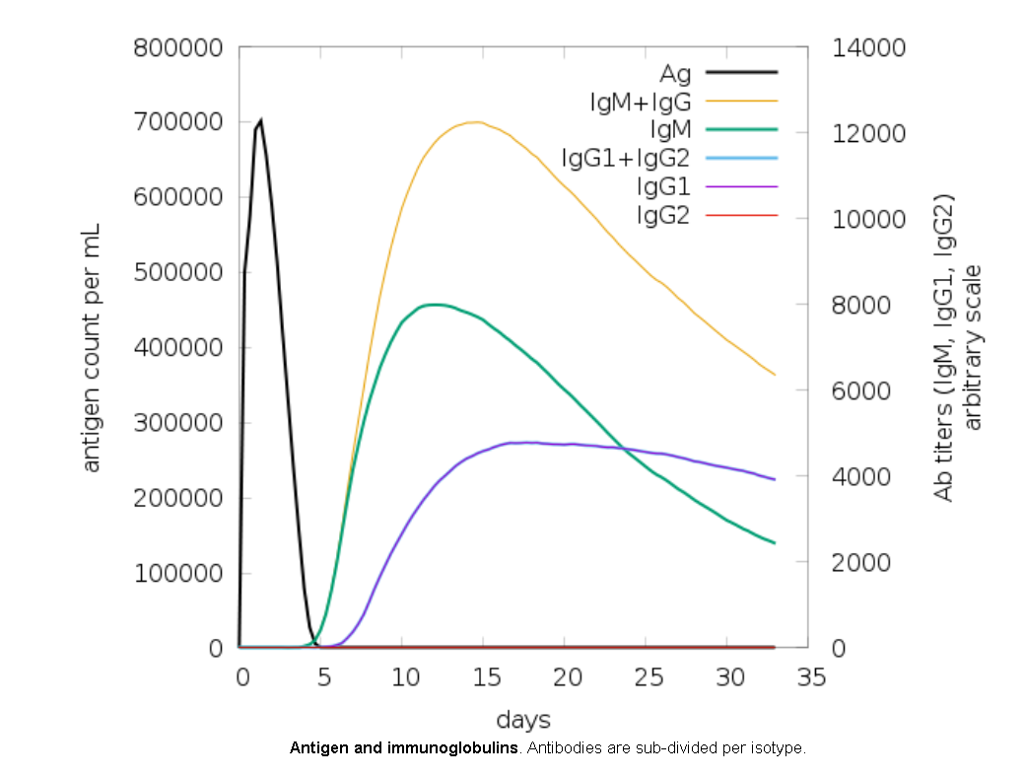

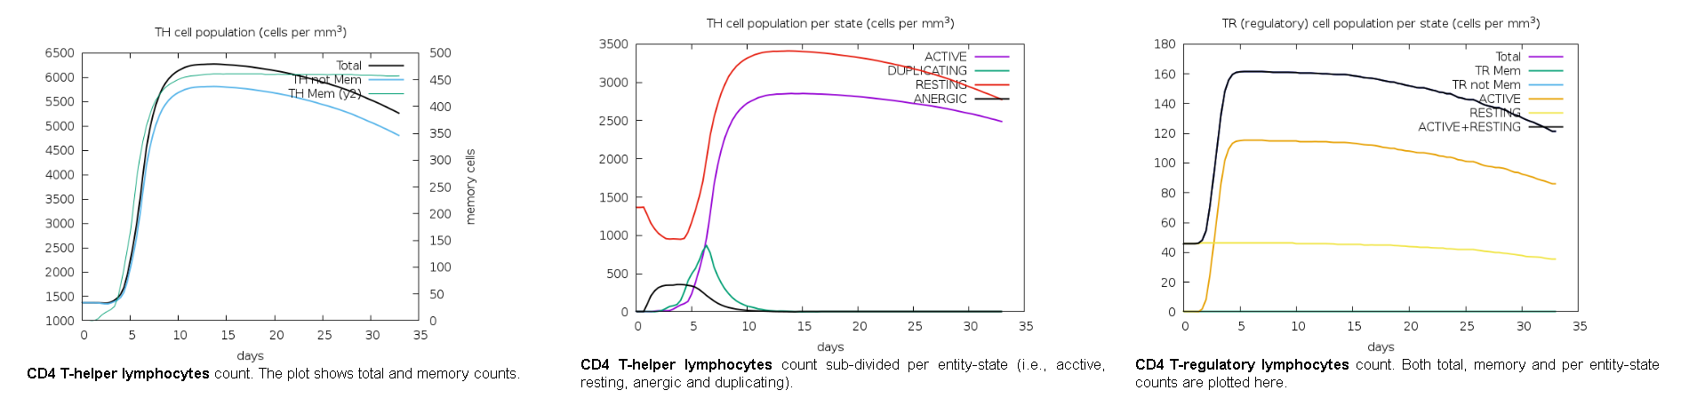



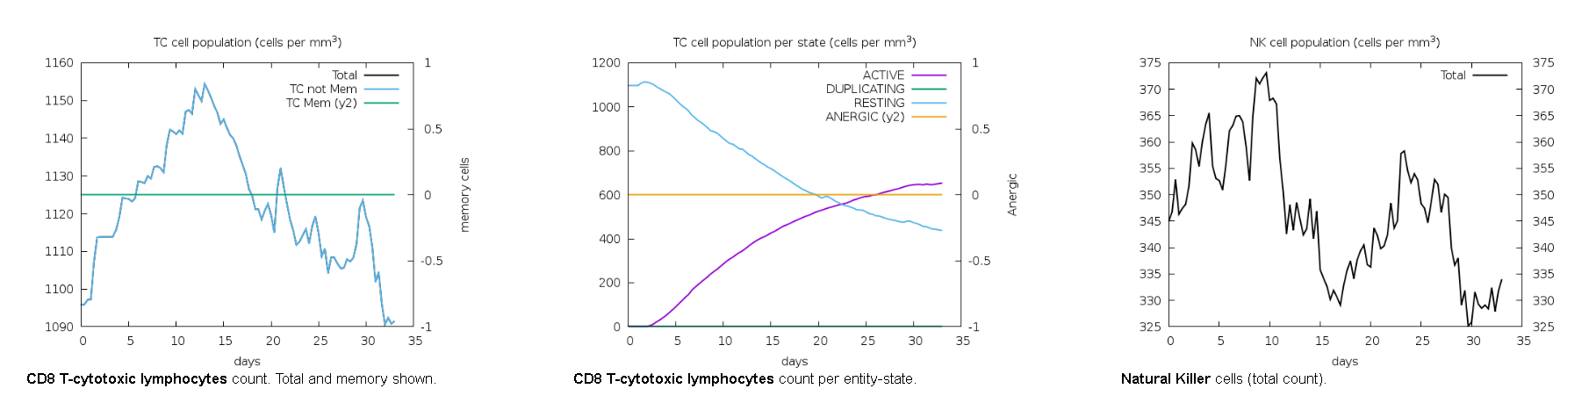

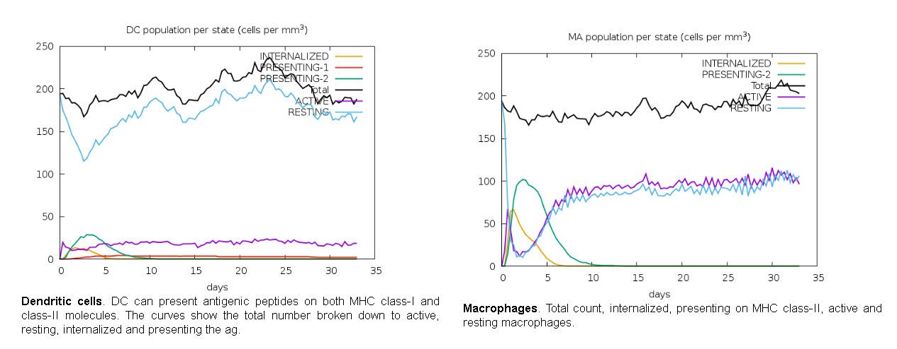





**Immune simulation analysis of vaccine construct by C-ImmSimm**